Parkinson’s Disease MRI Processing and ROI Signal Extraction

Project Description
This project implements an automated neuroimaging pipeline for analyzing functional MRI (fMRI) data from Parkinson’s disease patients and healthy control subjects. The goal is to preprocess resting-state BOLD images, normalize them into a standard brain space, and extract neural time-series signals from motor-related brain regions.
The pipeline integrates FSL neuroimaging tools with Python-based analysis to create a reproducible workflow for multi-subject MRI processing.
The workflow includes:
- Brain extraction from anatomical MRI
- Functional-to-structural image registration
- Structural-to-standard (MNI) normalization
- Nonlinear spatial transformation
- Atlas alignment
- ROI-based signal extraction

The extracted signals focus on motor network regions relevant to Parkinson’s disease, including:
- Primary Motor Cortex (M1)
- Supplementary Motor Area (SMA)
- Putamen
- Substantia Nigra

Data Source
The dataset used in this project is obtained from the Parkinson’s disease dataset provided by the 1000 Functional Connectomes Project (INDI).
Dataset link: https://fcon_1000.projects.nitrc.org/indi/retro/parkinsons.html
This dataset contains resting-state fMRI scans and anatomical MRI scans from both Parkinson’s disease patients and healthy control participants.
Dataset Summary
Total participants used in this project:
- 27 Parkinson’s Disease subjects
- 16 Healthy Control subjects
Total:
43 participants
Each subject contains two main MRI modalities:
Structural MRI
anat/*T1w.nii.gz
Functional MRI
func/*bold.nii.gz
The functional MRI images are 4D BOLD images, meaning they contain three spatial dimensions and one time dimension.

Software and Tools
Neuroimaging Software
The pipeline uses FSL (FMRIB Software Library) for MRI preprocessing and spatial registration.
FSL documentation: https://fsl.fmrib.ox.ac.uk/fsl/fslwiki

Main FSL tools used in this project:
Tool | Purpose
BET | Brain extraction
FLIRT | Linear registration
FNIRT | Nonlinear spatial normalization
EPI_REG | Functional-to-structural alignment
APPLYWARP | Apply spatial transformations

Python Libraries
The pipeline is automated using Python.
Libraries used:
- nibabel
- numpy
- pandas
- nilearn
- subprocess
- glob
- os
Purpose of the libraries:
- Nibabel – reading and writing NIfTI neuroimaging files
- NumPy – numerical computation and signal extraction
- Pandas – storing ROI time series
- Nilearn – atlas resampling and neuroimaging utilities
- Subprocess – running FSL commands from Python

Atlas for ROI Extraction
The project uses the AAL3 atlas for defining brain regions in standard MNI space.
Atlas file:
AAL3v1_1mm.nii.gz
Selected motor-related regions used for signal extraction:
Region | Atlas Label
M1 Left | 1
M1 Right | 2
SMA Left | 15
SMA Right | 16
Putamen Left | 77
Putamen Right | 78
Substantia Nigra pars compacta Left | 161
Substantia Nigra pars compacta Right | 162
Substantia Nigra pars reticulata Left | 163

Each region is processed individually without merging atlas labels.

Dataset Preparation
The dataset is organized using a BIDS-like directory structure.
Example subject folder:
dataset/
├── sub-001
│ ├── anat
│ │ └── sub-001_T1w.nii.gz
│ └── func
│ └── sub-001_bold.nii.gz
Where:
- anat/ contains the T1 structural MRI
- func/ contains the functional BOLD MRI
The pipeline automatically searches these folders to locate the necessary input files.

Processing Workflow
The pipeline processes each subject sequentially using the following steps.
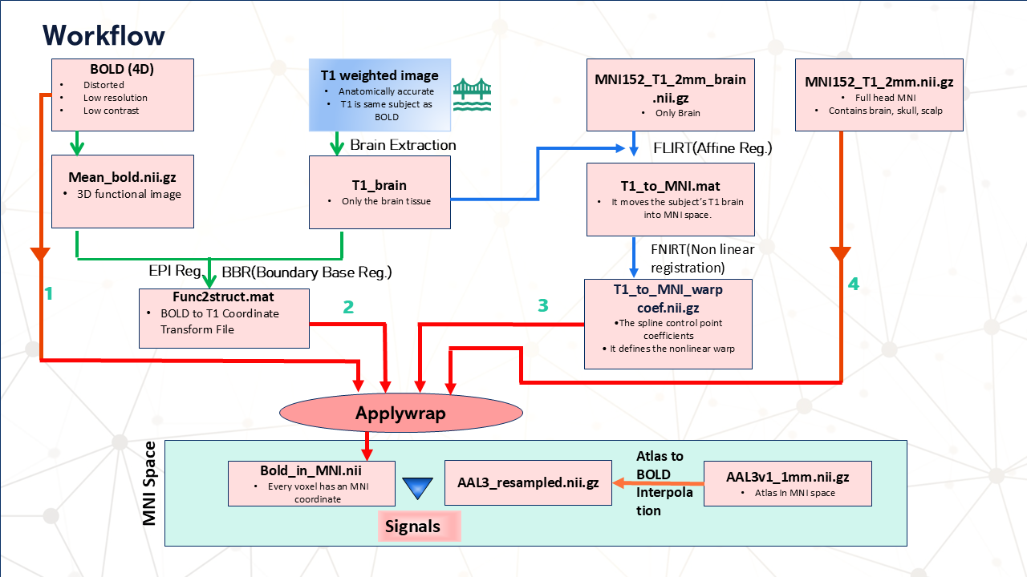
Figure: Workflow of the MRI preprocessing pipeline showing BOLD–T1 registration

Work Strategy for BOLD Signal Extraction*
The strategy for extracting BOLD signals from specific brain regions follows a structured sequence of preprocessing, spatial normalization, and atlas-based analysis. The goal is to ensure that functional MRI signals from all subjects are aligned to a common brain space and that region-specific neural activity can be consistently measured.
First, the functional BOLD images are aligned with the subject’s anatomical T1 images. This step ensures that the functional activity data corresponds accurately to the anatomical brain structure. The transformation is calculated using boundary-based registration, producing a matrix that maps BOLD space to T1 space.
Next, the anatomical T1 images are registered to the MNI standard brain template. This process involves both linear and nonlinear registration to achieve accurate spatial alignment across subjects. The resulting transformations allow the functional BOLD images to be normalized into the MNI coordinate system.
After computing these transformations, the applywarp tool is used to transform the original BOLD images into MNI space. This step ensures that the functional data shares the same spatial reference as the brain atlas used for region definition.
Since the atlas resolution may differ from the functional image resolution, the atlas is resampled to match the voxel grid of the normalized BOLD image. This ensures that each atlas label corresponds precisely to the correct BOLD voxels.
Finally, region-of-interest (ROI) signal extraction is performed. For each selected brain region, a mask is created using the atlas labels. All voxels belonging to that region are identified, and the mean BOLD signal across those voxels is computed for every time point. This produces a time-series signal representing neural activity in that specific brain region.
This strategy allows consistent extraction of BOLD signals from motor-related brain regions, enabling further analysis of neural activity patterns associated with Parkinson’s disease.

Step 1: Brain Extraction
The structural T1 image is processed to remove non-brain tissues such as the skull and scalp.
FSL command used:
bet T1.nii.gz T1_brain.nii.gz -f 0.5
Output file:
T1_brain.nii.gz
Step 2: Mean BOLD Image Generation
The 4D BOLD image is converted into a 3D reference image by averaging across the time dimension.
FSL command:
fslmaths bold.nii.gz -Tmean mean_bold.nii.gz
Output file:
mean_bold.nii.gz
This image is used as the reference image for functional registration.

Step 3: Functional to Structural Registration
The mean BOLD image is aligned to the subject's anatomical T1 image using Boundary Based Registration (BBR).
FSL tool:
epi_reg
Output transformation matrix:
func2struct.mat
This matrix maps:
BOLD space → T1 anatomical space

Step 4: Structural to MNI Linear Registration
The brain-extracted T1 image is registered to the MNI152 standard brain template using linear registration.
FSL tool:
flirt
Output transformation matrix:
T1_to_MNI.mat

Step 5: Nonlinear Spatial Normalization
To improve alignment accuracy, nonlinear registration is performed using FNIRT.
FNIRT computes a deformation field that maps the subject's anatomical image to the MNI template.
Output file:
T1_to_MNI_warpcoef.nii.gz

Step 6: Apply Warp to BOLD Image
The functional BOLD image is transformed into MNI standard space using the previously calculated transformations.
FSL command:
applywarp
Transformations applied:
- BOLD → T1 (func2struct.mat)
- T1 → MNI (warpcoef)
Output file:
bold_in_MNI.nii.gz

Step 7: Atlas Resampling
The AAL3 atlas is resampled to match the resolution and voxel grid of the normalized BOLD image.
Python function used:
resample_to_img()
Output file:
AAL3_resampled.nii.gz

Step 8: ROI Signal Extraction
For each region defined in the atlas:
- A region mask is created.
- Voxels belonging to that region are identified.
- The mean BOLD signal across those voxels is calculated.
This produces a time-series signal for each brain region.

Output Files
For each subject, the pipeline produces the following outputs.
Processed Images:
T1_brain.nii.gz
mean_bold.nii.gz
bold_in_MNI.nii.gz
AAL3_resampled.nii.gz
Transformation Files:
func2struct.mat
T1_to_MNI.mat
T1_to_MNI_warpcoef.nii.gz
Extracted ROI Signals:
ROI_individual_timeseries.csv
Each column of the output corresponds to a specific brain region, and each row represents the time point of the BOLD signal.

Further details of each step will be explained in the following document. Readers are encouraged to follow the document in order for a clearer understanding of the workflow.

